**ABSTRACT**

A NGO website is a project *that* aims to create an online platform for a non-governmental organization (NGO) to showcase its mission, vision, values, activities, achievements, and impact. A NGO website can help the organization to reach out to potential donors, supporters, partners, beneficiaries, and stakeholders, and to communicate its goals, needs, challenges, and successes. A NGO website can also facilitate online fundraising, advocacy, awareness, education, and engagement, and to provide information, resources, and services to the target audience .This software will provide a user-friendly environment in which the user of the system will be able to perform various operations like login, signup, read blog posts, comment on posts, read cards, and can donate also. This software is also reliable.

This project is a web based project providing online NGO (THE HOPE FOUNDATION) Management System for the people who want to donate online and become a member of this organization.. It is system which focuses mainly upon the resolving problem of the poor families and targets to fulfil it in a near time.

It allows the user to donate, register themselves and become our consistent member They may know of the details of our ongoing and achieved works through the website Each donor have their unique id and password.`

**CONTENTS**

**Abstract**

**Chapter 1: Introduction**

**(Few introductory lines about Computer Applications & importance)**

**Computer Application and Importance**

* 1. **Literature Survey**

**1.1.1 Previous related work in Chronological Order**

* 1. **Present State of System and Its ShortComings**
  2. **Realization of the Problem**
  3. **Work to be Taken Up**
  4. **Benefits of the Proposed System**
  5. **Broad Outline of the System**

**1.6.1 System Environment**

**Chapter 2: Problem Formulation**

**2.1 Problem Definition Detailed Description**

**2.2 Various Aspects of the Problem**

**2.3 Present System Critical View**

**2.4 Scientific Novelty and Need of the Work**

**Chapter 3: System Analysis & Design**

* 1. **Introduction**
  2. **Analysis Model**
  3. **Analysis of the System GUI**
  4. **Description of Various Modules**
  5. **E-R Diagram**
  6. **Data Flow Diagram**
  7. **Use Case Diagram**
  8. **Misuse Case Diagram**

**Appendix:**

**A1: E-R Diagram**

**A2:Data Flow Diagram(DFD)**

**A3: Use Case Diagram**

**CHAPTER-1**

**INTRODUCTION**

**NGO Objectives, Visions, and Missions**

**INTRODUCTION**

Non-profit organizations may provide a wide range of services, or they may offer just one or two. However, they all have something in common: they create objectives, visions, and missions to help them to carry out their work in a clear and organized way. They each play an important role in helping the organizations to carry out their tasks in a driven, motivated way, and they keep them on track and moving forward. They serve as a roadmap of how to reach their end goals and to identify what those end goals are.

**MISSION**

The Foundation for Social Change and Inclusion works for the social development and integration of underprivileged individuals, groups and communities

## VISION

**Our work aims to break the vicious cycle of poverty and social isolation and to restore hope for a better future. We believe that every person has the right to access resources and opportunities in order to live and develop with dignity and to become an active and contributing member of our society.**

**OBJECTIVES**

* To work for the social development of underprivileged individuals, groups and communities.
* To encourage healthcare development and health promotion.
* To assist in the process of social integration and personal realisation of underprivileged children, young people, adults and families.
* To encourage and popularise voluntary work.

**Module Description**

Modules used in this system are :-

1. Administrator.

2. Member

**Administrator :**

1. User Management:

- Create, edit, and delete user accounts.

- Reset passwords or provide access support.

2. Content Management:

- Create, edit, and delete pages and posts.

- Upload and manage media (images, videos, documents)

3. Website Configuration:

- Customize website appearance, themes, and layout.

- Manage site settings

4.Donation Management:

- Set up and manage online donation systems.

5. Feedback and Support:

- Receive and respond to user feedback

**Member:**

1. Profile Management

- Create and manage personal profiles.

- Update contact information and preferences.

2. Content Interaction:

- Comment on posts, articles

3. Donations and Contributions:

- Make online donations to support the NGO's activities.

4. Feedback and Support:

- Provide feedback on website content and functionality.

**FUNCTIONAL REQUIREMENTS**

Functional requirement include hardware requirements, software requirements, etc.

**Hardware Requirements**

Processor – Intel(R) Core(TM) i3-6100U or any latest version

RAM – 4GB or more

System Type – 32-bit or 64-bit

**Software Requirements**

Operation System – Windows 10 or any latest version

Browser – Google Chrome or any browser with latest version for best performance

**Language and Technology Used**

**Language used**

Frontend: HTML, CSS, JavaScript

The three main languages used in system development are HTML, CSS, and JavaScript. HTML provides the basic structure of sites, which is enhanced and modified by other technologies like CSS and JavaScript. CSS is used to control presentation, formatting, and layout. JavaScript is used to control the behavior of different elements

Backend: PHP-PHP is a server-side scripting language embedded in HTML in its simplest form. PHP allows web developers to create dynamic content and interact with databases. PHP is known for its simplicity, speed, and flexibility

**Database**

MySQL

It is the world's most popular open source database. With its proven performance, reliability and ease-of-use, MySQL has become the leading database choice for web-based applications

**Technology Used**

VS code

Visual Studio Code, also commonly referred to as VS Code, is a source-code editor made by Microsoft for Windows, Linux & MacOS. Features include support for debugging, syntax highlighting, intelligent code completion, snippets, code refactoring, and embedded Git.

XAMPP is a free and open source software that will allow to create a local web server on your computer. With XAMPP, you can develop and test web applications without the need of an internet connection or a hosting service.

**NON-FUNCTIONAL REQUIREMENTS**

Non-functional requirements of system includes the Feasibility study, which is further divided into Technical, Economic, Operational feasibility ,etc.

**1. Feasibility Study**

Feasibility study is made to see if the project on completion will serve the purpose of the organization for the amount of work, effort and the time that spend on it. Feasibility study of a system proposal is according to its workability, which is the impact on the organization, ability to meet their user needs and effective use of resources

**2. Technical Feasibility**

Technical feasibility focuses on the technical resources available to the organization. It helps organizations determine whether the technical resources meet capacity and whether the technical team is capable of converting the ideas into working systems. Technical feasibility also involves the evaluation of the hardware, software, and other technical requirements of the proposed system.The project is developed such that the necessary functions and performance are achieved within the constraints. The project is developed within latest technology. Though the technology may become obsolete after some period of time, but due to the fact that newer version of same software supports older versions, the system may still be used. So there are minimal constraints involved with this project. Hence, the project is technically feasible for development

**3. Economic Feasibility**

Economic feasibility typically involves a cost benefits analysis of the project, helping organizations determine the viability, cost, and benefits associated with a project before financial resources are allocated. It also serves as an independent project assessment and enhances project credibility helping

decision-makers determine the positive economic benefits to the organization that the proposed project will provide.The system has basic software and hardware requirements and can work on PC. Therefore, no manual cost to spend for the system.

**4. Operational Feasibility**

Operational feasibility involves undertaking a study to analyze and determine whether and how well the organization’s need could be met by completing the project. Operational feasibility studies also examine how a project plan satisfies the requirements identified in the requirements analysis phase of system development.

**OTHER NON-FUCTIONAL REQUIREMENTS**

This section includes various factors such as performance, reliability, availability, security, maintainability, portability, browser-compatibility

**1. Performance**:

Performance is the most important quality in non-functional requirements; it defines how fast a system can respond to a particular user’s action under a certain workload.

**2. Reliability**:

Reliability is the probability and percentage of software performing without failure for a specific number of uses or amount of time. Database updating follows transaction processing to avoid data inconsistency.

**3. Availability:**

This feature defines the amount of time the system is running. The project will be deployed on a public shared server so it will be available all the time and will be accessible anywhere of the world using internet.

**4. Security:**

Security measures ensure your software’s safety against sabotage or espionage.

**5. Maintainability:**

This feature indicates the average time and ease and rapidity with which a system can be restored after a failure. The system has been developed on HTML so anyone who has the knowledge of HTML, can easily maintain the system.

**6. Portability:**

Portability is the ease with which a software system can be transferred from its current hardware or software environment to another environment. This system is portable and we can switch the servers very easily.

**7. Browser Compatibility:**

Browser compatibility refers to web-based required compatibility with at least the popular web browsers. Microsoft Windows XP and above, Linux and Macintosh being the current popular operating system and Microsoft Internet Explorer, Mozilla Firefox, Opera, Safari and Google Chrome being the currently popular web browser. It can run on Chrome or any browser with latest version.

**COMPUTER APPLICATION AND IMPORTANCE**

Computers are now a fact of life. Computers have created a very effective information system to help streamline the management of an organization. It can be said of all large organizations, whether the department government or private, use a computer for a variety of their daily business and it is the fastest growing industries in the world today. Each organization usually has one or more large computer systems and a number of microcomputer. The system is a great computer for data processing tasks, while many small microcomputer to use as word processing. Computers have become part of our lives is essential. They are a fact of ife, a common threat that ties together our education, work and home life With computer touching nearly every facet of our lives, the issue of computer literacy becomes important. Consider the fact that computers are essential part of business today, whether you are an auto mechanic or a businessman, a journalist or an airline pilot. Like the cars that take us to work each day, we rely on computers more with each passing year.

* 1. **Literature Survey**

**1.1.1. Previous related work in chronological order**

The distribution of charity funds has never been equal and proportionate, rather the one who needs more gets less most of the time. The fund collected manually could not be managed properly with proper records, the data were stored in files which get lost very easily. Even when the online collection started at later stage, the problem of proper distribution remained. Moreover, the one who donate have already developed a sense of their money not being utilized at all. The people now needed to know the details or if not the details, a reliability that they are spending in the right direction. But the previous ways of manual collection as well as online collection did not keep up this level of reliability

**1.2. PRESENT STATE OF SYSTEM AND ITS SHORTCOMINGS**

The present state of art is completely computerized and everything is done through internet. Maintaining a state-of-the-art information system involves five elements including hardware, software, data, people and process. Hardware must be reliable and must be equipped to handle was works Software must carefully be designed and evaluated for its effectiveness All data must be enterest accurately to the computer.

This system will be designed in order to provide the donators with the details about the usage of their money and caring about the requirements of poor family’s basic needs, which otherwise would have been performed without any authenticity.

At the back end, the system allows the workers behind the scene (eg. DBA, developers etc) to manage the details of donations and raised funds in the form of appropriate tables in a database.

* 1. **REALIZATION OF THE PROBLEM**
* **Search for the needy**

People do not know for everyone who appears to be needy is really in need or not. They tend to search for the people who are in need actually which becomes quite cumbersome.

* **No details of usage of money**

The existing systems do not provide the details of the money donated. Whether the money is being utilized or not is not known to the donors once they donated.

**1.4. WORK TO BE TAKEN UP**

To overcome the problems of search for the needy and details of the usage of money, we expand our database and store the necessary information about the needy, donations received and further usage and achievement details.

**Advantages:**

* Less human error.
* Strength and strain of manual labor reduced.
* High security.
* Data redundancy can be avoided
* Data Consistency.
* Easy handling
* . Easy data updating.
* Easy record keeping.
* Backup data can be easily generated.

**1.5. BENEFITS OF THE PROPOSED SYSTEM**

* **Planned approach towards working**

The working of the system will be well planned and organized. The data will be stored properly in databases, which will help in retrieval of information as well as its storage.

* **Accuracy**

The level of accuracy in the proposed system will be higher. All operation would be done correctly and it will ensure that whatever information is coming from the center isaccurate.

* **Reliability**

The reliability of the proposed system will be high due to the above stated reasons. The reason for the increased reliability of the system is that now their would be proper storage of information.

* **No Redundancy**

In the proposed system utmost care would be that know information is repeated anywhere. in storage or otherwise. This would assure economic use of storage space and consistency in the data stored.

* **Immediate retrieval of information**

The main objective of proposed system is to provide for a quick and efficient retrieval of information. Any type of information would be available whenever the user requires

* **Immediate storage of information**

In manual system there are many problems to store the large amount of information.

* **Easy to operate**

The system should be easy to operate and should be such that it can be developed with in short period of time and fit in the limited budget of the user.

**1.6. BROAD OUTLINE OF THE SYSTEM**

**1.6.1. System Environment**

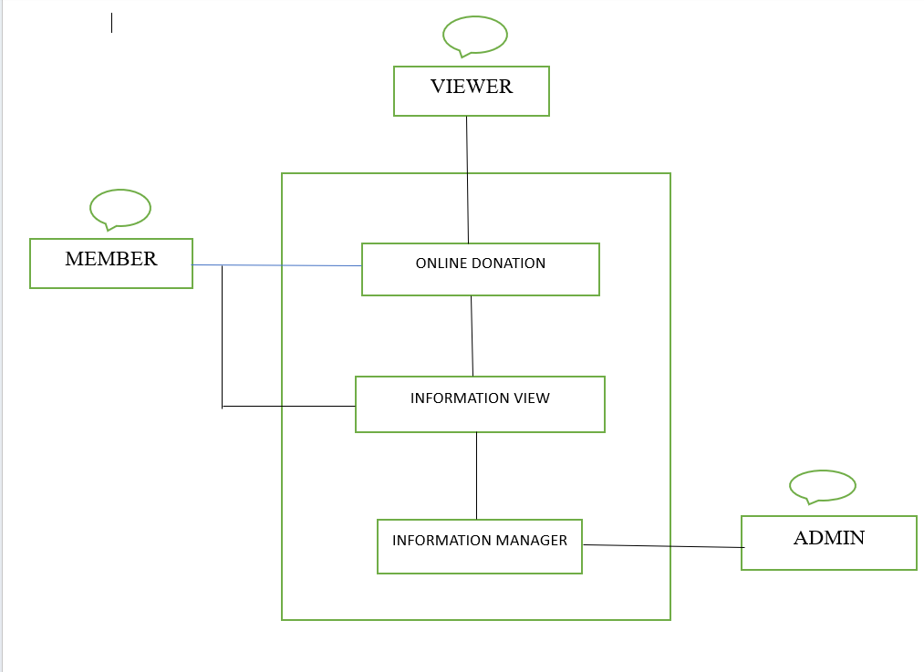

The Viewer visits the website through the Internet. They can donate by clicking on “donate now” button. The user can become member by registering himself/herself. They have access to know the cause where their donated money is utilized. Admin has the overall control for allowing the information that can be viewed by various actors.

The division of the NGO, into three component parts, the Online Public View, the information about donation and the information manager, is an example of using domain classes to make an explanation clearer.

**Chapter-2**

**PROBLEM**

**FORMULATION**

**2.1. PROBLEM DEFINITION DETAILED DESCRIPTION**

Problem formulation is one of the key steps in order to develop a software application. Therefore, in order to develop a new software, the first and foremost requirement is to study all the existing system, which provides all the information. The problem formulation is done to obtain a clear understanding of the needs of the client and users, and what is exactly desired from software. Thus keeping in mind each requirement of the user. While switching from windows to Windows, it has been noticed that there is no tool like task manager where the different system resources could be analyzed. And this led to think that a software should be built which could also analyze the performance of the system.

One of the problem is that we do not have any sort of application that can provide us various information regarding the system. Although we have tools that provide specific information about a particular device or resource but not all resources can be monitored in one tool.

**2.2. VARIOUS ASPECTS OF THE PROBLEM**

The system should get the users details such as name, email id, password etc. for the authentication and security purpose.

The software should provide search options. If a user intends to search for the details of the NGO works, he should be able to get that easily and in an organized fashion.

**2.3. PRESENT SYSTEM CRITICAL VIEW**

Not being user friendly, data redundancy and complexity of program is too large a major drawback; there is no facility to monitor the entry, search and deletion of the records as and when required in a comprehensive manner. This is very important to monitor to pin-point any shortcoming in the system resources which may be providing to be a bottle-neck for the overall system performance. So it is really very hectic and cumbersome for a system administrator to handle many records at the same time instantly.

The need for the new system arose from evaluation of deficiencies of the existing manual system which includes:

* Lack of Speed
* Inaccuracy
* Unreliability
* Uninformative

**2.4. SCIENTIFIC NOVELTY AND NEED OF THE WORK**

While designing this system it has been kept in mind that various phases of requirement may be fulfilled with ease and minimum efforts and in shortest possible time. The various enhanced and additional features of the system are:

* **USER FRIENDLY**: The main emphasis is angled on the most friendly user interface so that a native user or an end user or a person with least knowledge of computer can work on it and facilitate by the system. User interface is very friendly as on data entry screens in most of the fields the user just has to select from the dropdown list, which speeds up the data entry and also minimizes the chances of error occurring.
* **VALIDATIONS:** When any information related to either personal or project is changed, the user updates the tables corresponding to this change to prepare various reports, During the updating or insertion of data all kinds of validation is checked by the system itself.
* **VERIFICATION:** It is one of the most important software quality criteria. In verification we are mostly concerned with correctness. If an attempt is made to delete any data then the system do not directly carry out this job. It first sends a confirmation message by asking, &quot;Are you sure you want to delete this record? (Yes/No). Hence work is done only when user selects otherwise nothing happens.

**CHAPTER-3**

**SYSTEM ANALYSIS & DESIGN**

**3.1. INTRODUCTION**

After analysis the requirements of the task to be performed, the next step is to analyze the problem and understand its context. The first activity in the phase is studying the existing system and other is understanding the requirements and domain of the new system, both the activities are equally important, but the first activity serves as a basic of giving the functional specifications and then successful design of the proposed system. Understanding the properties and requirements of a new system is more difficult and requires creative thinking. Understanding of the existing system is also difficult. Improper understanding of present system can lead diversion from solution.

**3.2. ANALYSIS MODEL**

The model that is basically being followed is the Agile Model, which states that the phases are organized in a linear order. First of all the feasibility study is done. Once that part is over the requirement analysis and project planning begins. If system exists one then modification and addition of new module is needed, analysis of present system can be used as basic model.

The design starts after the requirement analysis is complete and the coding begins after the design complete. Once the programming is completed, the testing is done. In this model the sequence of activities performed in a software development project are:-

* Requirement Definition
* Designs
* Development
* Integration Test
* Installation & Acceptance

**3.3. ANALYSIS OF THE SYSTEM’S GUI**

For the flexibility of the users the interface has been developed as a graphics concept in mind, associated through a browser interface. The GUI at the top level have been categorized as:

* **Administrative user interface**
* **The Operational or generic user interface**

The **Administrative User Interface** concentrates on the consistent information that is practically, part of the organizational activities and which needs proper authentication for the data collection. The interfaces help the administrations with all the transactional states like data insertion, data deletion and data updating along with the extensive data search capabilities.

The **Operational or Generic User Interfac**e helps the users upon the systems in transactions through the existing data and requirement services. The operational user interface also helps the ordinary users in managing their own information in a customized manner as per the assisted flexibilities.

**3.4. DESCRIPTION OF VARIOUS MODULES**

The system after careful analysis has been identified to be presented with the following modules:

* Access Management module
* Student information setup and maintenance module
* Donors details module

**Access Management Module:** This module is used by the system admin to setup poor families data and what information should be available for which users.

**Raised fund maintenance module:** This module allows the authorized users to setup and maintain information related to fund raised by the organization.

**Donors details module**: This module allows the valid data entry from users to setup and maintain information related to the donors along with their personal and professional details.

**3.5.E-R DIAGRAM**

* The relation upon the system is structure through a conceptual E-R diagram which not only specifies the existential entities but also the standard relations through which the system exists and the cardinalities that are necessary for the system state to continue.
* The Entity-Relationship diagram (ERD) depicts the relation between the data objects. The ERD is the notation that is used to conduct the date modeling activity, the attributes of each noted in the ERD can be described in data object descriptions.
* The set of primary components that are identified by the ERD are
* Data Object
* Relationships
* Attributes
* Various types of indicators

The primary purpose of ERD is to represent data objects and their relationships.

**3.6.DATA FLOW DIAGRAM**

A data flow diagram (DFD) is graphically tool used to describe and analyze movement of data through a system. These are the central tool and the basis from which the other components are developed. It illustrates how data is processed by a system in terms of inputs and outputs. As its name indicates its focus is on the flow of information, where data comes from, where it goes and how it gets stored.

**Data Flow Diagram Levels**

A context diagram is a top level (also known as ;Level 0) data flow diagram. It only contains one process node (Process 0) that generalizes the function of the entire system in relationship to external entities.

**DFD Levels**

The first level DFD shows the main processes within the system. Each of these processes can be broken into further processes until you reach pseudo code.

**DFD Layers**

Draw data flow diagrams can be made in several nested layers. A single process node on a high level diagram can be expanded to show a more detailed data flow diagram. Draw the context diagram first, followed by various layers of data flow diagrams.

**Data Flow Diagrams Symbols**

There are essentially two different types of notations for data flow diagrams (Yourdon & Coad or Gane&Sarson) defining different visual representations for processes, data stores, data flow and external entities.

* **Process Notations**: A process transforms incoming data flow into outgoing data flow.
* **Datastore Notations**: Data store are repositories of data in the system. They are sometimes also referred to as files.
* **Dataflow Notations**: Dataflows are pipelines through which packets of information flow, Label the arrows with the name of the data that moves through it.

**Data flow**

**External Entity Notations**: External entities are objects outside the system, with which the system communicates. External entities are sources and destinations of the system’s inputs and outputs.

**3.7. USE CASE DIAGRAM**

A use case diagram at its simplest is a representation of a user’s interaction with the system that shows the relationship between the user and the different use cases in which the user is involved. A use case diagram can identify the different types of users of a system and the different use cases and will often be accompanied by other types of diagrams as well.

.

**APPENDIX**

**E-R DIAGRAM**

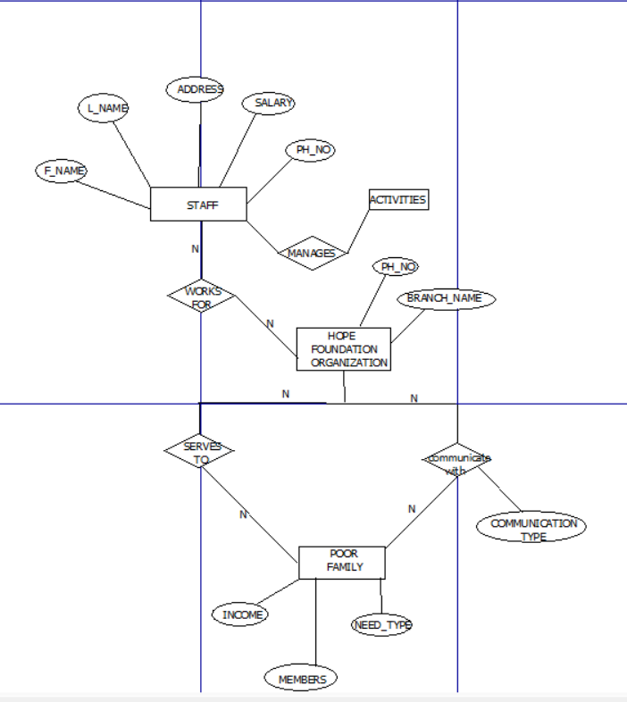

**DATA FLOW DIAGRAMS**

CONTEXT LEVEL/LEVEL 0

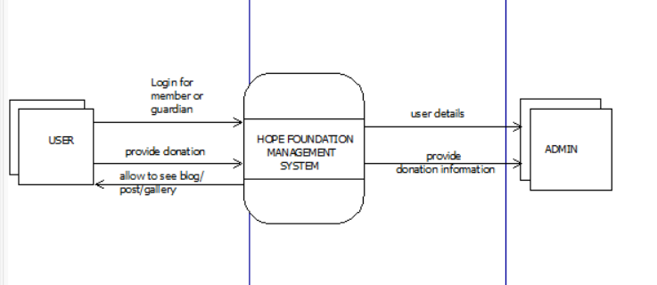

LEVEL-1

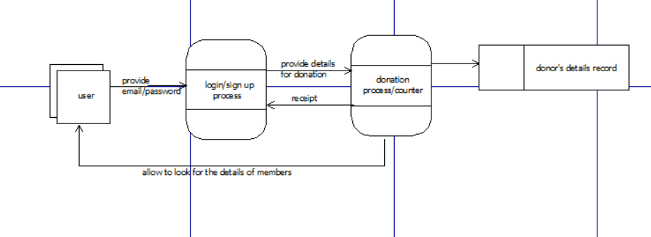

LEVEL-2

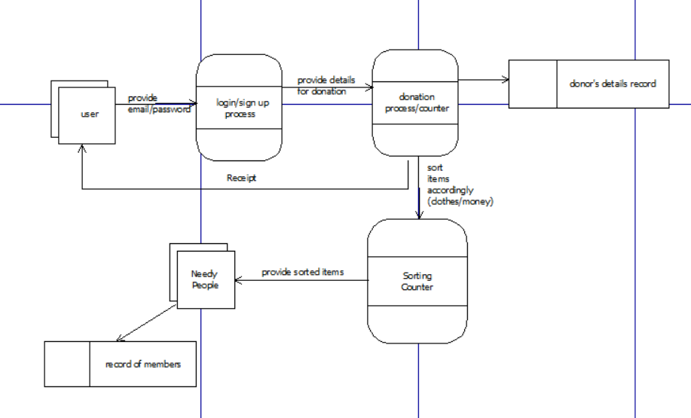

**USE CASE DIAGRAM**

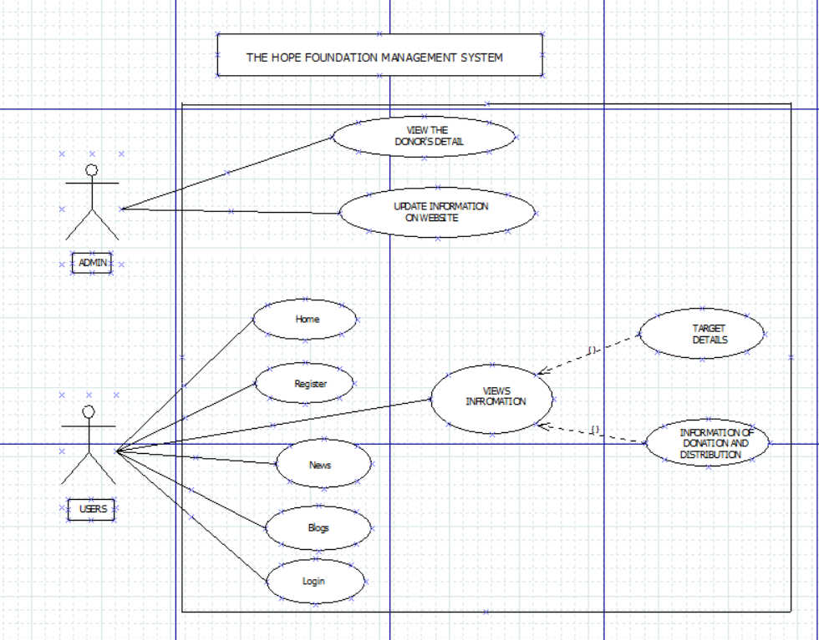

**REFERNCES**

* <https://youtube.com/playlist?list=PLu0W_9lII9aikXkRE0WxDt1vozo3hnmtR&si=T4xXtxMgEE-sUVPo>
* <https://www.w3schools.com/>
* <https://quillbot.com/>
* <https://cssgradient.io/>
* <https://www.media.io/>
* <https://stock.adobe.com/>

Activity diagram for user

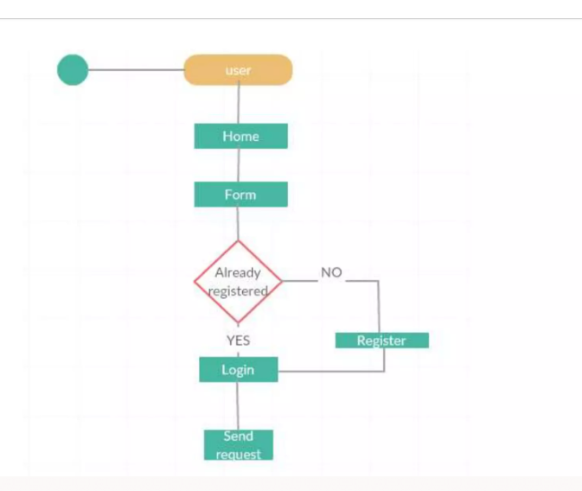

Activity diagram For admin

